Argentina

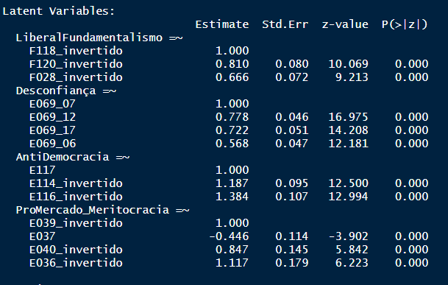

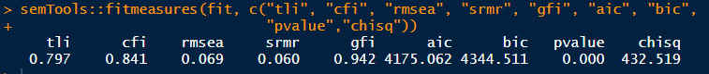

% partido mais citado – Justicialista = 27,8%

|  |  |  |  |  |
| --- | --- | --- | --- | --- |
| Justicialista | Justicialista | Justicialista | Justicialista |  |
| Predictors | Odds Ratios | Odds Ratios | Odds Ratios | Odds Ratios |
| (Intercept) | 3.71 * (1.93) | 0.36 *** (0.03) | 0.19 *** (0.05) | 1.64  (1.00) |
| region32002 | 1.31  (0.28) |  |  | 1.33  (0.30) |
| region32006 | 0.72  (0.21) |  |  | 0.64  (0.19) |
| region32013 | 1.20  (0.37) |  |  | 0.97  (0.31) |
| region32021 | 1.00  (0.28) |  |  | 0.88  (0.26) |
| region32024 | 0.72  (0.23) |  |  | 0.75  (0.25) |
| Gender | 0.73  (0.12) |  |  | 0.84  (0.15) |
| idade_faixa | 0.83  (0.09) |  |  | 0.78 * (0.09) |
| escolaridade_niveis | 0.41 *** (0.06) |  |  | 0.38 *** (0.06) |
| status_emploSelf Employed | 1.11  (0.27) |  |  | 1.07  (0.27) |
| status_emploHousewife | 1.27  (0.32) |  |  | 1.30  (0.35) |
| status_emploRetired | 1.15  (0.31) |  |  | 1.02  (0.28) |
| status_emploStudent | 0.40 * (0.17) |  |  | 0.32 ** (0.14) |
| status_emploOthers | 1.08  (0.24) |  |  | 1.17  (0.27) |
| rend_subjLow | 1.24  (0.27) |  |  | 1.38  (0.32) |
| rend_subjMedium | 0.92  (0.20) |  |  | 0.98  (0.22) |
| rend_subjHigh | 1.92 * (0.54) |  |  | 1.79 * (0.53) |
| religionDo not belong to a denomination | 0.36 *** (0.09) |  |  | 0.51 * (0.14) |
| religionOthers | 0.82  (0.20) |  |  | 0.86  (0.23) |
| fundamentalism |  | 1.88  (0.92) | 1.42  (0.71) | 1.23  (0.67) |
| antidemocr |  | 3.12  (2.65) | 2.55  (2.21) | 1.59  (1.46) |
| desconfia |  | 0.06 *** (0.03) | 0.06 *** (0.03) | 0.09 *** (0.04) |
| promercado |  | 2.63  (2.44) | 1.68  (1.59) | 4.18  (4.19) |
| autoloc_dir_esqCenter |  |  | 1.75  (0.50) | 1.74  (0.53) |
| autoloc_dir_esqRight |  |  | 2.91 *** (0.84) | 3.11 *** (0.95) |
| autoloc_dir_esqDon't Know |  |  | 1.78  (0.57) | 1.56  (0.52) |
| interesse |  |  | 0.90  (0.22) | 1.33  (0.36) |
| Observations | 1079 | 1079 | 1074 | 1074 |
| R2 Tjur | 0.093 | 0.061 | 0.078 | 0.165 |
| * p<0.05   ** p<0.01   *** p<0.001 | | | | |

#

BRASIL

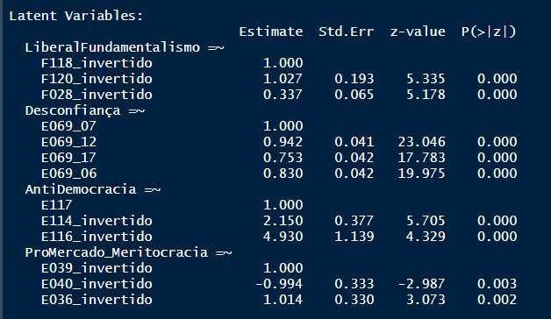PT = 23,4% da amostra



|  |  |  |  |  |
| --- | --- | --- | --- | --- |
|  | PT_ | PT_ | PT_ | PT_ |
| Predictors | Odds Ratios | Odds Ratios | Odds Ratios | Odds Ratios |
| (Intercept) | 0.21 * (0.13) | 0.30 *** (0.02) | 0.40 *** (0.06) | 0.38  (0.25) |
| Gender | 1.16  (0.18) |  |  | 1.17  (0.19) |
| X049 | 1.09 * (0.04) |  |  | 1.10 * (0.05) |
| raca_brancTRUE | 0.77  (0.13) |  |  | 0.80  (0.14) |
| idade_faixa | 0.73 ** (0.09) |  |  | 0.73 * (0.09) |
| escolaridade_niveis | 1.38 * (0.18) |  |  | 1.06  (0.15) |
| status_emploSelf Employed | 1.30  (0.36) |  |  | 1.18  (0.35) |
| status_emploHousewife | 0.62  (0.16) |  |  | 0.65  (0.18) |
| status_emploRetired | 1.59  (0.47) |  |  | 1.57  (0.48) |
| status_emploStudent | 1.25  (0.41) |  |  | 1.15  (0.39) |
| status_emploOthers | 1.32  (0.25) |  |  | 1.40  (0.27) |
| rend_subjLow | 1.07  (0.38) |  |  | 1.04  (0.39) |
| rend_subjMedium | 0.96  (0.37) |  |  | 0.84  (0.34) |
| rend_subjHigh | 0.78  (0.41) |  |  | 0.55  (0.31) |
| religionCatholic | 0.62 * (0.13) |  |  | 0.65  (0.15) |
| religionOther Christian (Evangelical/Pentecostal) | 0.92  (0.24) |  |  | 1.04  (0.29) |
| religionOthers | 0.46  (0.20) |  |  | 0.57  (0.26) |
| fundamentalism |  | 0.02 * (0.03) | 0.02 * (0.03) | 0.05  (0.10) |
| antidemocr |  | 0.00 * (0.00) | 0.00 * (0.00) | 0.00  (0.00) |
| desconfia |  | 3.90  (2.88) | 5.04 * (3.90) | 3.29  (2.65) |
| promercado |  | 0.00  (0.00) | 0.00  (0.00) | 0.00  (0.00) |
| autoloc_dir_esqCenter |  |  | 0.50 *** (0.10) | 0.49 *** (0.10) |
| autoloc_dir_esqRight |  |  | 0.39 *** (0.07) | 0.40 *** (0.07) |
| autoloc_dir_esqDon't Know |  |  | 0.46 ** (0.12) | 0.51 * (0.14) |
| interesse |  |  | 2.22 *** (0.51) | 2.52 *** (0.62) |
| Observations | 1143 | 1143 | 1138 | 1138 |
| R2 Tjur | 0.047 | 0.025 | 0.066 | 0.100 |
| * p<0.05   ** p<0.01   *** p<0.001 | | | | |

#

Chile – partido mais citado – DC 21,3%

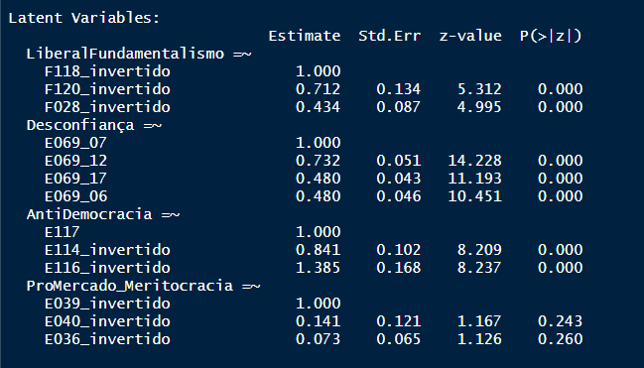

Obs abrimos mão de pró-mercado

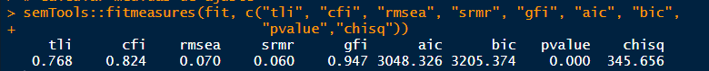

|  |  |  |  |  |
| --- | --- | --- | --- | --- |
|  | DC_ | DC_ | DC_ | DC_ |
| Predictors | Odds Ratios | Odds Ratios | Odds Ratios | Odds Ratios |
| (Intercept) | 0.14  (0.23) | 0.26 *** (0.02) | 0.25 *** (0.05) | 0.26  (0.46) |
| Gender | 1.24  (0.24) |  |  | 1.20  (0.25) |
| X049 | 1.06  (0.23) |  |  | 0.99  (0.22) |
| region152003 | 0.63  (0.46) |  |  | 0.34  (0.26) |
| region152004 | 1.07  (0.62) |  |  | 0.95  (0.57) |
| region152005 | 0.33  (0.37) |  |  | 0.24  (0.27) |
| region152006 | 0.93  (0.41) |  |  | 0.68  (0.31) |
| region152007 | 2.30  (1.18) |  |  | 1.14  (0.62) |
| region152008 | 0.42  (0.31) |  |  | 0.28  (0.21) |
| region152009 | 1.36  (0.77) |  |  | 0.90  (0.53) |
| region152010 | 0.43  (0.37) |  |  | 0.35  (0.31) |
| region152012 | 1.16  (0.64) |  |  | 0.67  (0.39) |
| region152013 | 0.64  (0.47) |  |  | 0.50  (0.43) |
| region152014 | 0.80  (0.31) |  |  | 0.61  (0.25) |
| region152015 | 0.58  (0.43) |  |  | 0.49  (0.38) |
| region152016 | 1.04  (0.45) |  |  | 0.77  (0.35) |
| idade_faixa | 1.23  (0.16) |  |  | 1.20  (0.16) |
| escolaridade_niveis | 0.77  (0.12) |  |  | 0.75  (0.12) |
| status_emploSelf Employed | 1.03  (0.27) |  |  | 1.05  (0.29) |
| status_emploHousewife | 0.97  (0.23) |  |  | 1.09  (0.27) |
| status_emploRetired | 0.66  (0.23) |  |  | 0.70  (0.26) |
| status_emploStudent | 0.61  (0.24) |  |  | 0.56  (0.23) |
| status_emploOthers | 0.74  (0.22) |  |  | 0.90  (0.28) |
| rend_subjDK | 0.97  (0.38) |  |  | 1.19  (0.48) |
| rend_subjLow | 0.67  (0.18) |  |  | 0.82  (0.23) |
| rend_subjMedium | 0.89  (0.21) |  |  | 0.98  (0.24) |
| religionCatholic | 1.89 * (0.55) |  |  | 1.68  (0.50) |
| religionOthers | 1.58  (0.54) |  |  | 1.30  (0.47) |
| fundamentalism |  | 3.31 * (1.72) | 3.01 * (1.58) | 1.98  (1.13) |
| antidemocr |  | 0.07 *** (0.06) | 0.04 *** (0.03) | 0.05 *** (0.04) |
| desconfia |  | 0.41 ** (0.14) | 0.46 * (0.16) | 0.43 * (0.16) |
| autoloc_dir_esqCenter |  |  | 1.52  (0.35) | 1.47  (0.36) |
| autoloc_dir_esqRight |  |  | 1.40  (0.33) | 1.29  (0.32) |
| autoloc_dir_esqDon't Know |  |  | 0.46 * (0.15) | 0.46 * (0.15) |
| interesse |  |  | 0.74  (0.22) | 0.92  (0.29) |
| Observations | 989 | 1000 | 988 | 977 |
| R2 Tjur | 0.038 | 0.023 | 0.047 | 0.079 |
| * p<0.05   ** p<0.01   *** p<0.001 | | | | |

#

méxico partido mais citado: PRI 26,3%

Latent Variables:

Estimate Std.Err z-value P(>|z|)

LiberalFundamentalismo =~

F118_invertido 1.000

F120_invertido 1.655 0.277 5.985 0.000

F028_invertido 0.585 0.074 7.956 0.000

Desconfiança =~

E069_07 1.000

E069_12 1.568 0.086 18.215 0.000

E069_17 1.468 0.085 17.204 0.000

E069_06 1.549 0.087 17.903 0.000

AntiDemocracia =~

E117 1.000

E114_invertido 1.677 0.288 5.821 0.000

E116_invertido 2.147 0.379 5.671 0.000

ProMercado_Meritocracia =~

E039_invertido 1.000

E040_invertido 0.573 0.114 5.027 0.000

E036_invertido 0.401 0.084 4.774 0.000

> # Calcular medidas de ajuste

> semTools::fitmeasures(fit, c("tli", "cfi", "rmsea", "srmr", "gfi", "aic", "bic",

+ "pvalue","chisq"))

tli cfi rmsea srmr gfi aic bic pvalue chisq

0.898 0.923 0.044 0.041 0.977 5342.974 5513.210 0.000 233.149

|  |  |  |  |  |
| --- | --- | --- | --- | --- |
|  | PRI_ | PRI_ | PRI_ | PRI_ |
| Predictors | Odds Ratios | Odds Ratios | Odds Ratios | Odds Ratios |
| (Intercept) | 3.35 * (1.67) | 0.35 *** (0.02) | 0.24 *** (0.05) | 2.51  (1.40) |
| Gender | 0.99  (0.14) |  |  | 1.04  (0.15) |
| X049 | 0.89 *** (0.02) |  |  | 0.90 *** (0.03) |
| idade_faixa | 0.88  (0.08) |  |  | 0.82 * (0.08) |
| escolaridade_niveis | 0.64 *** (0.07) |  |  | 0.60 *** (0.07) |
| status_emploSelf Employed | 1.06  (0.20) |  |  | 0.93  (0.18) |
| status_emploHousewife | 1.11  (0.22) |  |  | 1.01  (0.21) |
| status_emploStudent | 0.73  (0.18) |  |  | 0.68  (0.17) |
| status_emploOthers | 0.96  (0.16) |  |  | 0.87  (0.15) |
| rend_subjDK | 0.39 ** (0.12) |  |  | 0.40 ** (0.13) |
| rend_subjLow | 0.51 ** (0.13) |  |  | 0.56 * (0.15) |
| rend_subjMedium | 0.75  (0.19) |  |  | 0.75  (0.20) |
| religionCatholic | 1.17  (0.18) |  |  | 1.07  (0.17) |
| religionOthers | 0.52 ** (0.12) |  |  | 0.46 ** (0.11) |
| fundamentalism |  | 3.70 * (1.94) | 4.43 ** (2.44) | 2.50  (1.47) |
| antidemocr |  | 17.92  (27.73) | 8.83  (14.17) | 3.52  (5.97) |
| promercado |  | 2.82 * (1.42) | 3.25 * (1.67) | 3.83 * (2.08) |
| desconfia |  | 0.18 ** (0.10) | 0.25 * (0.15) | 0.23 * (0.14) |
| autoloc_dir_esqCenter |  |  | 1.13  (0.24) | 1.17  (0.26) |
| autoloc_dir_esqRight |  |  | 2.47 *** (0.46) | 2.43 *** (0.47) |
| autoloc_dir_esqDon't Know |  |  | 1.02  (0.25) | 0.90  (0.23) |
| interesse |  |  | 0.82  (0.18) | 1.02  (0.23) |
| Observations | 1476 | 1510 | 1459 | 1428 |
| R2 Tjur | 0.055 | 0.023 | 0.057 | 0.105 |
| * p<0.05   ** p<0.01   *** p<0.001 | | | | |

#Peru

Cambio 90 – 37,8% da amostra – partido mais citado

Latent Variables:

Estimate Std.Err z-value P(>|z|)

LiberalFundamentalismo =~

F118_invertido 1.000

F120_invertido 1.014 0.418 2.422 0.015

F028_invertido 0.256 0.104 2.458 0.014

Desconfiança =~

E069_07 1.000

E069_12 0.756 0.055 13.819 0.000

E069_17 0.848 0.064 13.228 0.000

E069_06 0.894 0.068 13.217 0.000

AntiDemocracia =~

E117 1.000

E114_invertido 1.988 0.303 6.554 0.000

E116_invertido 2.150 0.354 6.079 0.000

ProMercado_Meritocracia =~

E039_invertido 1.000

E040_invertido 0.766 0.129 5.934 0.000

E036_invertido 0.431 0.082 5.250 0.000

> semTools::fitmeasures(fit, c("tli", "cfi", "rmsea", "srmr", "gfi", "aic", "bic",

+ "pvalue","chisq"))#refazer sem antidemoc

tli cfi rmsea srmr gfi aic bic pvalue chisq

0.862 0.896 0.044 0.035 0.975 4215.917 4379.091 0.000 197.568

|  |  |  |  |  |
| --- | --- | --- | --- | --- |
|  | Cambio90_ | Cambio90_ | Cambio90_ | Cambio90_ |
| Predictors | Odds Ratios | Odds Ratios | Odds Ratios | Odds Ratios |
| (Intercept) | 0.57  (0.28) | 0.60 *** (0.04) | 0.65  (0.18) | 0.66  (0.41) |
| Gender | 0.87  (0.13) |  |  | 0.91  (0.14) |
| raca_brancTRUE | 1.08  (0.20) |  |  | 1.07  (0.21) |
| idade_faixa | 0.80 * (0.07) |  |  | 0.77 ** (0.08) |
| status_emploSelf Employed | 1.95 *** (0.38) |  |  | 1.78 ** (0.36) |
| status_emploHousewife | 1.64 * (0.35) |  |  | 1.49  (0.33) |
| status_emploStudent | 0.98  (0.22) |  |  | 0.92  (0.21) |
| status_emploOthers | 1.18  (0.21) |  |  | 1.11  (0.21) |
| rend_subjDK | 0.98  (0.38) |  |  | 0.91  (0.36) |
| rend_subjLow | 1.33  (0.49) |  |  | 1.18  (0.44) |
| rend_subjMedium | 1.34  (0.50) |  |  | 1.25  (0.48) |
| religionCatholic | 1.13  (0.27) |  |  | 1.18  (0.31) |
| religionOthers | 1.48  (0.44) |  |  | 1.65  (0.52) |
| fundamentalism |  | 2.53  (1.70) | 1.98  (1.39) | 1.79  (1.28) |
| antidemocr |  | 1.57  (1.85) | 1.13  (1.38) | 0.89  (1.10) |
| desconfia |  | 0.27 ** (0.11) | 0.33 ** (0.14) | 0.38 * (0.16) |
| promercado |  | 2.03  (0.92) | 2.19  (1.03) | 2.47  (1.19) |
| autoloc_dir_esqCenter |  |  | 1.68 * (0.37) | 1.66 * (0.38) |
| autoloc_dir_esqRight |  |  | 1.92 ** (0.42) | 2.02 ** (0.45) |
| autoloc_dir_esqDon't Know |  |  | 1.13  (0.28) | 1.21  (0.31) |
| interesse |  |  | 1.45  (0.30) | 1.49  (0.32) |
| escolaridade_niveis |  |  | 0.73 ** (0.07) | 0.73 ** (0.08) |
| Observations | 1201 | 1211 | 1175 | 1166 |
| R2 Tjur | 0.023 | 0.011 | 0.030 | 0.050 |
| * p<0.05   ** p<0.01   *** p<0.001 | | | | |

#

Uruguai

partido mais citado: Frente Amplio (29,5%)

Latent Variables:

Estimate Std.Err z-value P(>|z|)

LiberalFundamentalismo =~

F118_invertido 1.000

F120_invertido 1.172 0.136 8.604 0.000

F028_invertido 0.438 0.060 7.266 0.000

Desconfiança =~

E069_07 1.000

E069_12 0.954 0.045 21.263 0.000

E069_17 0.769 0.046 16.850 0.000

E069_06 0.711 0.044 16.149 0.000

AntiDemocracia =~

E117 1.000

E114_invertido 2.147 0.346 6.206 0.000

E116_invertido 4.088 0.916 4.461 0.000

ProMercado_Meritocracia =~

E039_invertido 1.000

E040_invertido 1.004 0.162 6.215 0.000

E036_invertido 0.457 0.074 6.133 0.000

> semTools::fitmeasures(fit, c("tli", "cfi", "rmsea", "srmr", "gfi", "aic", "bic",

+ "pvalue","chisq"))#refazer sem antidemoc

tli cfi rmsea srmr gfi aic bic pvalue chisq

0.853 0.889 0.064 0.056 0.955 3654.830 3811.878 0.000 298.557

|  |  |  |  |  |
| --- | --- | --- | --- | --- |
|  | FrenteAmplio_ | FrenteAmplio_ | FrenteAmplio_ | FrenteAmplio_ |
| Predictors | Odds Ratios | Odds Ratios | Odds Ratios | Odds Ratios |
| (Intercept) | 6.08  (11.08) | 0.36 *** (0.03) | 2.49 ** (0.85) | 10.15  (24.17) |
| Gender | 1.27  (0.21) |  |  | 1.16  (0.25) |
| region858007 | 0.62  (0.29) |  |  | 1.00  (0.59) |
| region858009 | 0.62  (0.30) |  |  | 0.69  (0.42) |
| region858010 | 1.23  (0.88) |  |  | 0.97  (0.89) |
| region858011 | 1.01  (0.29) |  |  | 1.01  (0.40) |
| region858012 | 0.64  (0.34) |  |  | 1.08  (0.71) |
| region858014 | 0.18 ** (0.12) |  |  | 0.34  (0.27) |
| region858019 | 0.49  (0.21) |  |  | 0.71  (0.40) |
| X049 | 0.90  (0.27) |  |  | 1.05  (0.41) |
| raca_brancTRUE | 0.85  (0.30) |  |  | 0.66  (0.29) |
| idade_faixa | 0.54 *** (0.06) |  |  | 0.63 ** (0.10) |
| status_emploSelf Employed | 1.20  (0.32) |  |  | 0.85  (0.31) |
| status_emploHousewife | 0.58 * (0.15) |  |  | 0.62  (0.21) |
| status_emploStudent | 0.33 ** (0.11) |  |  | 0.39 * (0.19) |
| status_emploOthers | 0.80  (0.15) |  |  | 0.83  (0.21) |
| rend_subjDK | 0.80  (0.27) |  |  | 1.56  (0.69) |
| rend_subjLow | 0.73  (0.17) |  |  | 1.27  (0.44) |
| rend_subjMedium | 0.79  (0.15) |  |  | 1.06  (0.30) |
| religionCatholic | 0.42 *** (0.07) |  |  | 0.54 ** (0.12) |
| religionOthers | 0.63  (0.15) |  |  | 0.69  (0.22) |
| fundamentalism |  | 0.07 *** (0.03) | 0.32 * (0.17) | 0.46  (0.26) |
| antidemocr |  | 0.00 *** (0.00) | 0.00 * (0.01) | 0.00 * (0.01) |
| desconfia |  | 1.30  (0.47) | 1.37  (0.70) | 0.95  (0.52) |
| promercado |  | 0.41  (0.20) | 0.67  (0.42) | 0.75  (0.48) |
| autoloc_dir_esqCenter |  |  | 0.07 *** (0.02) | 0.07 *** (0.02) |
| autoloc_dir_esqRight |  |  | 0.03 *** (0.01) | 0.03 *** (0.01) |
| autoloc_dir_esqDon't Know |  |  | 0.05 *** (0.02) | 0.05 *** (0.02) |
| interesse |  |  | 1.87 * (0.59) | 2.14 * (0.71) |
| escolaridade_niveis |  |  | 0.94  (0.14) | 0.83  (0.15) |
| Observations | 1000 | 1000 | 990 | 990 |
| R2 Tjur | 0.110 | 0.137 | 0.461 | 0.481 |
| * p<0.05   ** p<0.01   *** p<0.001 | | | | |

---

Tabela – onda 3 – resultados da análise fatorial confirmatória

ver tabelas resultados analise fatorial confirmatoria.xlsx